**SCSM2.5D Manual**

SCSM2.5D is the 2.5D wave modeling program with subdomain Chebyshev spectral FDM. 2.5D modeling generates 3D wavefield in 2D geological model, which is suitable for seismic line survey. Program is made of FORTRAN 90 (MainOMP.f90, C_DF.f90, Gauss_Quad.f90, Grid_Model.f90, interp.f90, MATRIX_YYXZ.f90, MS_DF.f90, Viscoelastic.f90, Viscoelastic2.f90). Replacing MainOMP.f90 with MainMPIOMP.f90 becomes MPI/OpenMP version for fully-parallel computation (employing cores same number of wavenumber sampling, and computation time become less than 1.5 times of 2D modeling runtime).

1. Input data

1.1 2.5Dseis_SCSM.inp

MODD NT Source: f0 t0

MODD: 2D (0) or 2.5D (1)

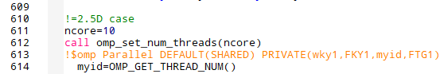

In MainOMP.f90, Line 611, You can determine the number of core for 2.5D modeling.

NT: Number of time marching steps

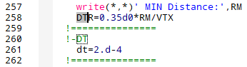

In MainOMP.f90, Line 261, You can determine the time segment (dt).

F0: Source central frequency of Rickers wavelet

T0: Time delay of source (at least 0.05s recommended and inverse relation with F0)

DX DZ NORDX NORDZ

DX: Subdomain size of x coordinate

DZ: Subdomain size of z coordinate

NORDX: Subdomain points along x coordinate

NORDZ: Subdomain points along z coordinate

INTERFACES DATA NFS

INTERFACES DATA: The first figure is number of interfaces and second figure is number of points along x-coordinate. E.g., 2 and 41 present single layer (homogeneous media) having 41 points for subdomain.

NFS: 0 for full space or 1 for free surface

-----------* 1 *------------------

Following two columns represent interface data along x-coordinates and z-coordinates

-EXTERNAL MODEL?-

EXTERNAL MODEL: Whether employ the complex model (1) or not (0).

If yes, you need extra input file (c11.inp, c13.inp, c33.inp, c44.inp, c66.inp, rho.inp, theta.inp). For viscoelastic anisotropy, you need strain relaxation times (tau_ep_11.inp, tau_ep_13.inp, tau_ep_33.inp, tau_ep_44.inp, tau_ep_66.inp) and stress relaxation times (tau_sig_11.inp, tau_sig_13.inp, tau_sig_33.inp, tau_sig_44.inp, tau_sig_66.inp). Our program receives the model parameter from deeper to shallow depth but receiving the EXTERNAL MODEL from shallow to deeper depth.

-INDP- -Model-

Model parameters: Number of model should be Interface – 1. E.g., interface=2 & model=1 for homogeneous media, interface=4 & model=3 for 3 layer model.

The first number is the independent number. 1=acoustic, 2=isotropy, 3=VTI-2, 4=VTI-1, 5= General VTI, 6=ORT.

The second line is {Density, Independent moduli}.

The third line is tilted angle for TTI (1) or not (0).

The fourth line is tilted angle ($0^{°}\sim {360}^{°}$).

-NSV-

The first and second figure are source point location within subdomain E.g., 1 1 is left bottom. The third figure is source vector (x-direction (1) or z-direction (3)).

-MAB- -DMAX- -Efact-

The first figure is PML (1) or SRM (2). The second figure is PML parameter and the third is SRM parameters.

-----Source & Receiver Location (NSR, X,Z coordi)

The first figure is number of Source + Receiver. The second line is x- and z-coordinate of source points. The following others are receiver locations. However, source and receivers doesn’t located on the free surface even if you put the proper z-coordinates. You can manually fix that in MainOMP.f90.

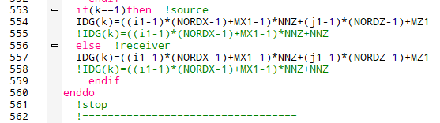

Line 553~555 determine the location of source. MX1 and MZ1 are the input data in -NSV- (location within subdomain). NNZ is the number of z-coordinates. Line 555 fix the source position on the top of grid (free surface). Line 557~558 are receiver’s location.

* 1. relaxation_time.inp

VISCO | RECURSIVE | Nhete

The first figure viscoelastic (1) or elastic (0). The second figure is recursive convolution method (1) or partial differential equations method (0). The third figure is number of layers, and should match the layers in 2.5Dseis_SCSM.inp.

Next line e.g.

5 3

3.5774296952513399E-002 6.7481038667282700E-003 1.6313910723490001E-003

2.2805059493937799E-002 4.7530094027435996E-003 8.9270249012923103E-004

3.5774296952513399E-002 6.7481038667282700E-003 1.6313910723490001E-003

2.2805059493937799E-002 4.7530094027435996E-003 8.9270249012923103E-004

3.5774296952513399E-002 6.7481038667282700E-003 1.6313910723490001E-003

2.2805059493937799E-002 4.7530094027435996E-003 8.9270249012923103E-004

3.5774296952513399E-002 6.7481038667282700E-003 1.6313910723490001E-003

2.2805059493937799E-002 4.7530094027435996E-003 8.9270249012923103E-004

3.5774296952513399E-002 6.7481038667282700E-003 1.6313910723490001E-003

2.2805059493937799E-002 4.7530094027435996E-003 8.9270249012923103E-004

1 3

3.5774296952513399E-002 6.7481038667282700E-003 1.6313910723490001E-003

2.2805059493937799E-002 4.7530094027435996E-003 8.9270249012923103E-004

The first media (deeper) has 5 independent quality factors (VTI) with 3 standard linear solid bodies. The order of each lines are {$τ_{ϵ}^{(11)}$, $τ_{σ}^{(11)}$, $τ_{ϵ}^{(13)}$, $τ_{σ}^{(13)}$*, $τ_{ϵ}^{(33)}$* , $τ_{σ}^{(33)}$*, $τ_{ϵ}^{(44)}$* , $τ_{σ}^{(44)}$*, $τ_{ϵ}^{(66)}$* , $τ_{σ}^{(66)}$}. If you choose the TTI media in 2.5Dseis_SCSM.inp, it will automatically calculate in given tilted angle. The next media has 1 independent quality factor (acoustic) with 3 standard linear solid bodies. The order of each lines are {$τ_{ϵ}^{(M)}$, $τ_{σ}^{(M)}$}. I’ll attach the calculation of relaxation times in matlab code.

1. Output data

2.1 Wavefield figure

Wavefield figure is generated only in 2D modeling. Figure have fort.1xx {$v_{x}^{solid}$}, fort.3xx {$v_{z}^{solid}$}, fort.4xx {$P_{}^{water}$}, fort.5xx {$v_{x}^{water}$}, fort.7xx {$v_{z}^{water}$} and grid coordinates {Xgrid.out, Zgrid.out}. You can manage the frequency of figure generation in C_DF.f90.

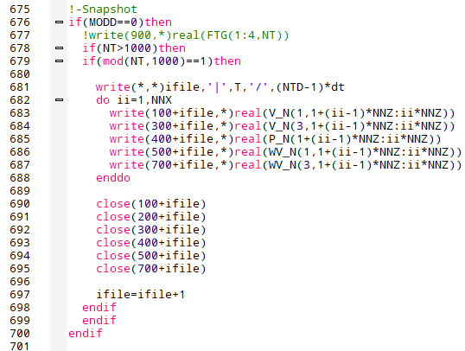

Line 678, if(NT>1000): figure generate after 1000 time step.

Line 679, if(mod(NT,1000)==1): figure generate every 1000 time step.

* 1. Seismogram

Seismogram result is recorded in rec_real_x.out. rec_real_1 is the receiver in the source point and after rec_real_2 ~ x are the receivers. rec_real_x.out file has 14 row in order {t, , , , , , , , , , , , , }.

* 1. Misc

Test1.out ~ Test6.out are the test output to check the program read or generate the proper parameters in given input data. E.g., In MainOMP.f90

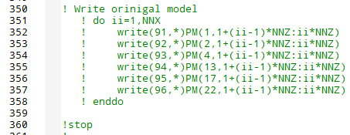

Line 350, there are the test example of model parameters. PM(1,:) is the density information in whole nodes PM(2:22,:) are the elastic moduli information.

1. Job submission to HPC

OpenMP job submission, runOMP.sh.

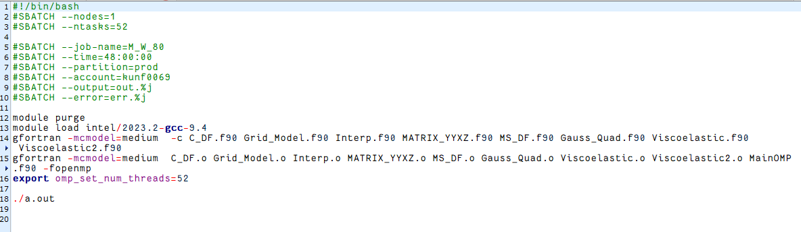

You can only employ the single node of HPC with OpenMP parallel. Our HPC has 2CPUs and 26 cores each CPUs, so runOMP.sh employ the 52 cores in this file. Meanwhile, MPI/OpenMP can cooperate CPUs of multiple nodes.

MPI/OpenMP job submission, runMPIOMP.sh

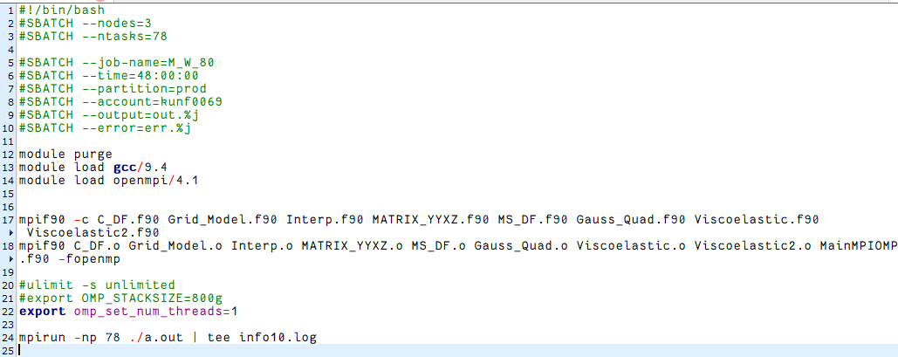

MPI enable to employ CPUs from multiple nodes. runMPIOMP.sh is the example of three CPUs (78 cores) from three HPC nodes. Because of the faster waiting queue in HPC, we show employing single CPUs from each node.

1. Problem solution

4.1 Artificial reflection

You may meet the artificial reflection in your seismogram or snapshot. You can manually increase the thickness of absorbing layers. In MainOMP.f90,

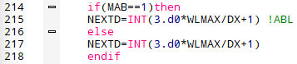

Line 214 check PML (215) or SRM (217). NEXTD is the number of absorbing subdomains, and you can change 3 -> 4, 5, 6…., so that problem will be solved.

4.2 2.5D modeling optimization

Although you successfully obtain the 2D, 2.5D result could have some problems despite the same 2D model.

First is the seismic wave oscillation after the first arrival (Figure a). This is caused by not enough cutoff wavenumber (Maximum wavenumber). In MainOMP.f90,

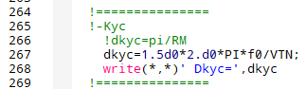

Line 267, you can increase 1.5 -> 2.0…

Second is the artificial reflection in 2.5D (Figure b), which isn’t shown in 2D. This is caused by not enough wavenumber sampling (Nky). In MainOMP.f90,



Line 595, you can increase 1.2 -> 1.5…, so that you avoid the artificial reflections in 2.5D modeling.

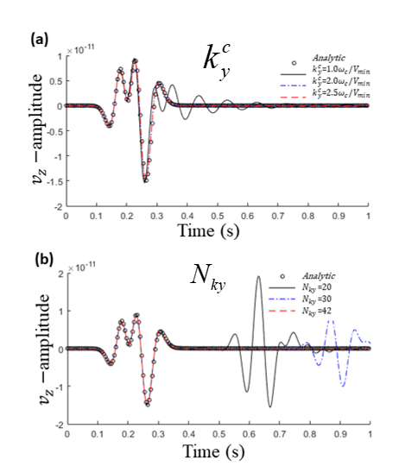

4.3 Match with analytical solutions

When you try to match with analytical solutions, our results will show more lower source frequency than analytical solution. This is because program employ the gaussian distributed source.

In C_DF.f90,



Line 105, RS determine the area of source distribution.

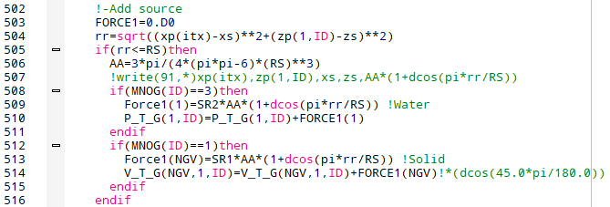

Line 507, you can write the x, z of distributed source and x, z of center source, and each point’s weighting factor. If you generate the same analytical solutions of distributed source locations and sum them up with gaussian weight, you will see the analytical solution match.